Human Computer Interaction

How to make coffee.  
Focusing on step 2; Measure out the coffee grounds

Introduction:   
My name is Nikkolas James Diehl and I will be using this essay as a medium to discuss visual perception with some light discussion on haptic perception and cognitive perception.

“The bodies of humans and brutes according to Descartes were complex machines” (Lederer, 2008)., From the retina allowing visual imaging to the ossicles that transmits sound waves to the inner ear or the tailbone still existing in the human body even when we do not need it, the human body contains many complex systems. And when it comes down to it, individual menial tasks or instructions require a great deal of complex bodily control.  
This essay is going to examine the physiological and biological processes the body undergoes when measuring out coffee grounds to make a coffee. Firstly the focus of this discussion will be on the visual aspects of our eyes as they receive the 3D world, followed by a brief introduction to the mechanics of the eyeball in relation to receiving images. Secondly, the essay will focus on depth and volume detection; discussing how the haptic and visual perceptions work together to achieve this. Thirdly, a cultural aspect to our visual perception and how the visual perception is heavily tied to how we learn, what we learn and the practices we adopt. This adds a dimension that is often not considered. Finally; the impact of ageing and changing bodies will be discussed as they greatly affect how we perceive the world using our senses.

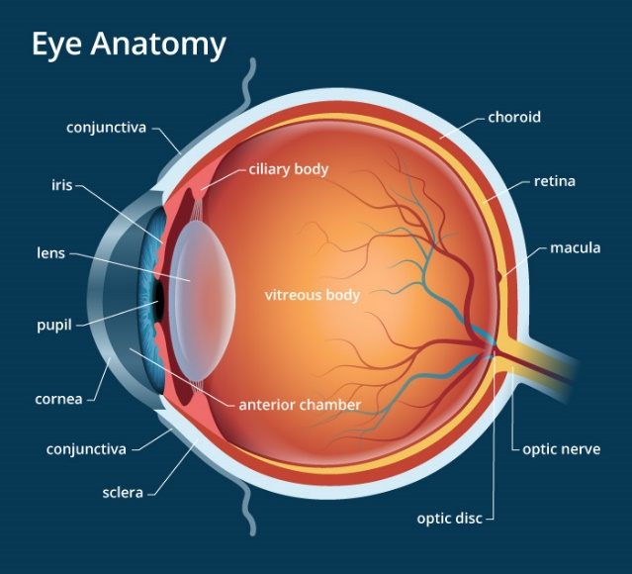Visual aspects and the Mechanics of the Eye:   
The visual perception is very interesting because the way we perceive the world is different for almost everyone due to changes in awareness and the world around us. The coffee grinds will be perceived via visual stimuli first before any other sense, and as the user begins to measure the coffee grinds, many visual and cognitive processes start occurring. Light from the coffee grinds streams to our eyes which is then captured by our retina, sent along our optic nerve and into the brain which is responsible for translating the light into understandable images. On a deeper level, the complexity of the eye also receives colour, depth and detail. Colour is perceived using the red, green, and blue colour cones which are all mostly packed into the fovea centralis in the eye (Nave, 2016). Depth comes from both eyes sending two slightly off-centre images to the brain which are then merged (Mitsukura & Satoh, 2018) and detail comes from the light being focused through our lenses onto the retina (Tetlan & Marschalek, 2016).

Figure 1: Eye Anatomy: Parts of the Eye (Bagi, 2017)

Recognising Objects:   
The advancement of understanding how the human eye transmits its vision to the brain began around the mid 1900’s with many researchers such as Roger Sperry and S.M. Kosslyn using brain imaging technologies to find out how adults absorb the world (Tetlan & Marschalek, 2016). Reality and the 3D world around could be described as trillions of points of energy that release light. Our eyes then pick up the stray light and recreate a deceiving 2D image based on what and where the light comes from. The information of the light; its traits and characteristics are determined on the matter it is released from, and so as Spillmann, L., and Werner, J. (1990) said: “Light provides the medium in which objects make their energy imprints…”   
Once the light enters our eyes, the first step in recognizing, say, the coffee grounds situation, is our retina captures the visual stimuli from the viewed situation and sends this captured light to the optic nerve via the lateral geniculate (Tetlan & Marschalek, 2016). After the image is sent to the optic nerve, it is sent directly to the visual cortex which lies within the optical lobe, further sitting in the frontal lobe within the brain. In order to do all of this, the eye needs to use the full scope of light as it varies and changes across objects (Spillmann & Werner, 1990).   
The changes and characteristics of the light come from the material makeup of an object. Objects vary greatly in reflectance, tessellation, occlusion, light density, shape, and volume and so on. The coffee grounds are dark and are quite granular which results in an ununiformed tessellated texture that creates occlusion shadows within its own volume making the grounds look even darker than they really are. The light is also bent and varied by the shape, size and material of the measuring device we use. As this constantly shifting light reaches our eyes, our retina absorbs the light as visual stimuli and sends it to our brain. From there, our brain undergoes many different cognitive procedures to understand that we are holding and measuring coffee.

Depth Perception:   
Depth perception or stereopsis is a very important part of the visual stimuli as it helps us visualise 3D reality much better than just viewing an image and is an extremely crucial part of the human behaviour when interacting with the 3D space such as for social interactions (HyunGoo, Dora, & Gregory, 2016 Jun 16). Depth perception is the ability to converge the vision from both eyes into a 3D vision and works to better describe the world we see. It is crucial to determining the length, width, height and volume of an object (Rebuild Your Vision, 2014).   
Depth is one of the most important ingredients of visual perception as its goal is to quickly and efficiently understand our 3D environment of which we occupy. Because of this, a clear knowledge of how our 3D world is laid out is important to see the relationship between objects, light and our own bodies (Patten, 2013). Depth perception is also paramount to visual affordance; the ability to view something and immediately know its value, what it is for and where it is used (Soegaard, 2005). With the coffee grounds, depth perception is used to obtain information on the grounds depth within the measuring device and thus the amount we want to measure as well as determining the weight based on the affordance we give it.

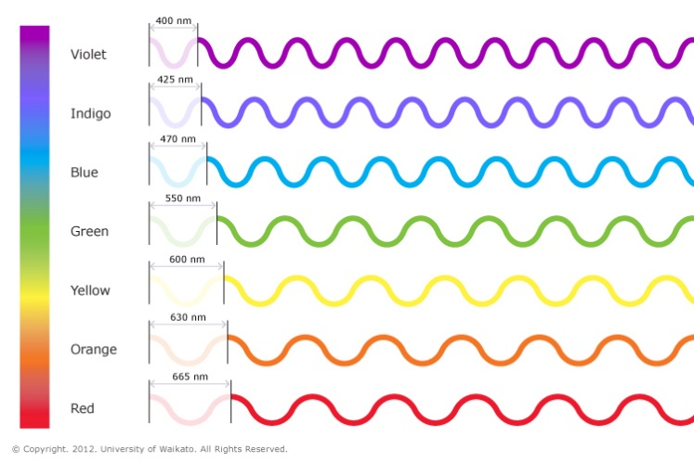Colour & Light:   
Colour vision or colour perception is the ability to evaluate ‘colour’ in objects from just the electromagnetic differences in the light regardless of the power of the light (Kelber, 2016). Thus the colour and vibrancy of the world around us is astonishing based on the idea that colour in of itself does not exist as we understand it. Colour is entirely a human observed phenomenon and is seen when objects with different material and molecular makeup are hit by white light (polychromatic light) and based on the object, different wavelengths are absorbed, whilst others are reflected. Black objects are the result of when all wavelengths of light are absorbed thus nothing is reflected and sent to our eyes. And white coloured objects are caused from when all wave lengths are reflected back to our eyes. The amount of light reflected or absorbed determines the ‘visual strength’ of the colour and in some rare instances, almost all light can be either absorbed or reflected. Vantablack, for example, is a substance that absorbs 99.965% of all light and is so black it loses form (NanoSystems, 2016).   
With the human body, we are only able to perceive a small part of the light spectrum and whilst the entire electromagnetic spectrum is extensive and spans from radio waves at kilometre wide wavelengths to gamma rays with wavelengths shorter than an atom (Banke, 2015) we only get a glimpse at it. The colour spectrum is all that the human eye can perceive and contains a range of vibrant colours; Violet being a 400nm wave, Indigo: 425nm, Blue: 470, Green: 550nm, Yellow: 600nm, Orange: 630nm and Red being 665nm.   
When the light finally enters our eye, based only on its wavelength, we will perceive different colours (Hub, 2016). This colour perception or full-colour vision is very unique to humans and a rare few other animal species as the ability to see colours based on different wavelengths of light comes from three receptors, or more commonly called the cones in the human eye held together in a mosaic; the (S) short cone, (M) medium and (L) long cone (Roorda & Williams, 1999).  
Prior to these receptors (cones) primates, such as mammals and especially nocturnal animals developed the use of ‘rods’ which allowed sight but where severely colour lacking. Some animals even had or have a colourless vision (Gonçalves dos Santos Martins & Fontes de Azevedo Costa, 2018). But as evolution carried our race forward, we developed the use and the eventual need for colour perception. In the coffee grounds example, being able to recognize colour is extremely important to make sure the coffee grounds are untampered and uncorrupted. If we did not have the ability to see colour, in our example, one might miss something like salt mixed in with the grounds.

Figure 2: The visible spectrum (Waikato, 2012)

Volume Detection:   
Volume can be explained by how much space an object takes up within a space thus, volume detection or volume perception is crucially important to the human race, our behaviours and our lifestyles. Volume detection comes from how your brain processes the visual stimuli coming from two eyes at slightly different angles with each other. The two images from each eye are overlaid together and melded to form a 3D viewpoint from two 2D images coming from our eyes (LumenCandela, 2013).  
Volume perception comes hand in hand with depth perception and the ability to visualise, or think of the world in 3D and strongly helps with architecture design, software development and many other important tasks. In the coffee grounds example; by using the visual and haptic perception, we are able to perceive exactly how much to measure based entirely on our senses and no other external subsidiary because the ability to tell the differences in the volume of a given object based on our haptic and visual perception is significant (Zhang, et al., 2018).   
Even in marketing, volume perception is extremely important and can be used as both a selling point, but can also be abused to trick consumer’s perception of volume. An example for this is English beer which can be sold in two different glasses: the Carlsberg glass or the Fosters glass. The Carlsberg is taller but thinner, whilst the Fosters is shorter but much fatter. Both are exactly one pint of beer (Raghubir & Krishna, 1999).   
There are many facets to solid objects and the world around us. Colour and light make up some parts of the visual data of an object. And the material can make up the haptic data of an object; what the object feels like to the touch. But some facets of an object cross over perceptions like in the case of volume. One of the determining factors of a solid object is volume as it has information on the special size of an object (Zhang, et al., 2018).   
Studies have found as well that haptic perception greatly increases the accuracy of volume perception. In our measuring coffee grounds example, limiting volume detection to just the visual perception can result in inaccurate volume detection due to varying angles and viewing platforms (Chen, Lee, Lee, & Chen, 07/08/2017). In the study, the implied conclusion indicated the fault to be depth perception being suppressed via viewing angles.

Culture & its Ties to the Visual Perception:   
Culture differences in the world are very important for us as humans because not only do they define who we are and how we react to certain changes, but they also directly impact and are impacted by our bodily perceptions. Culture, specifically, has a profound impact on how we see the world and our visual perception.   
Bodily perceptions such as haptics, sound, hearing and especially the visual stimuli are not just used to perceive something, but also to gain an affordance of an objects meaning and with a large repertoire of differing cultures, there are quite a number of cultural misunderstandings.   
The thumbs up, for example, is a symbol of approval and thanks in most western cultures but is seen as an offensive gesture in Islamic and Asian cultures (Kastanakis & Voyer, 2014). This is because we see the world not just as scattered objects, but as a defined meaningful environment and because we’re looking at the meaning of something rather than the object itself, our definition of an objects meaning changes with our culture (Inchan & Yeonkoo, 2018).   
With the coffee grounds example as you measure the grounds, culture is taken into account because for different places in the world, different measurement systems are used. In the United States of America, when holding a measuring device with coffee grounds inside, they would automatically be thinking in ounces. Whilst anywhere else in the world, when holding the same device, would automatically think in grams when measuring.  
For most studies and systems in place, it has been generally alluded to that ‘thinking’ and perceiving is a universal process and that we all view information and meaning the exact same way but cross-culture studies over the last couple of decades have shown that some cultures, such as the Murray Islanders in Melanesia and members of the Toda tribe in India actually had few, if 0 errors when shown visual illusions made to trick the eye due mostly to cultural upbringing and differences in how they view the world (Masuda, 2009). It was also found that measurement lines such as numbers and time measurements are ordered differently across different cultures. In most western cultures, we usually order given items in linear lines but in some other cultures like Papua New Guinea lack ordered measurement lines and linear systems and thus, when ordering linearly, will order a given collection of objects somewhat randomly with scattered items (Cooperrider, Marghetis, & Núñez, 2017).   
This is all due to the different visual environments in which members of varying cultures are born into. Each environment and culture has many different facets to it that force different habitual learning schemes and different ways we visualise our world (Acar, Taura, Yamamoto, & Yusof, 2011). All the way, for example, from housing and old architecture in Australia being completely built from stone and brick because wood was destroyed by the termites that prevail over the country, to different measurement systems in America due to the fact that they never had the time, money, resources or will to change from something that was already working in the rest of the original colonial countries for hundreds of years.   
Based on an innumerable number of cognitive procedures, our brain utilises cultural learning and environmental learning (Inchan & Yeonkoo, 2018) to understand that we are holding and measuring coffee grounds.

Ageing and its Effects on Perception:   
Entropy; the ultimate judge, jury and executioner. It affects every single living organism in the entire universe and brings us, step by step, to the precipice of death. Because of this, as the human body grows older and decays, its perceptions and movement are slowly drained.   
Ageing can be described as the body deteriorating in a linear function as our perceptions necessary for life are destroyed (Gillbert, 2004). With the visual perception, the visual stimuli are directly tied to the cognitive perception as our brains are needed in order to interpret visual stimuli. Visual stimuli are sent or stored in the visual working memory (VWM) and this place in the brain is heavily affected by age and deterioration due to the fact that it’s tied into memory (Greenlee & Sekuler, 2014).   
Studies found proof of this visual deterioration with age and found that the VWM continues to grow up until it reaches a maximum memory size at ages around 20. After that, the VWM has a sharp decline in size and by the age of 55, adults start to experience a greater reduction in visual perception and visual memory than 8 or 9-year-olds (Greenlee & Sekuler, 2014). Other studies also concluded that ageing also affects the ability to track moving objects (Shain & Norman, 2018), discern the depth in a given situation properly thus resulting in dizziness and that the ageing process also impeded the aesthetic judgements in older adults (Greenlee & Sekuler, 2014).  
In the coffee grounds example, ageing plays a great part in the visual memory relied upon for this and many other daily activities. An elder might experience trouble measuring the coffee grounds due to depth perception being impeded and making the measurements look greater or lesser than required and might have trouble connecting their visual stimuli to instructions on what to do in their heads due to massively reduced visual working memory (Bordaberry, Gerlach, & Lenoble, 2017).

Conclusion:   
In conclusion, the visual and haptic perceptions greatly affect our everyday life. From colour perception being granted with the help of colour receptors on our retina to depth perception being a result of the visual perception correlating to the cognitive perception wherein your brain processes the two images from each eye into a 3D visualisation. The visual perception is fascinatingly complex. It can’t be fully separated as its own perception since it relies on visual memory, culture, haptic feedback, colour and a multitude of other bodily functions.  
Measuring the coffee correctly takes a surprisingly great deal of bodily control and perception to achieve such a mundane task but yet an immense amount of effort discreetly goes into making this task possible.

# References

(n.d.).

Acar, A., Taura, T., Yamamoto, E., & Yusof, N. F. (2011). Object vs. Relation: Understanding the Link between Culture and Cognition with the Help of WordNet. *Colips, 21*(4), pp. 199-208. Retrieved from http://www.colips.org/journals/volume21/21.4.3-objectvsrelationsinal.pdf

Bagi, S. (2017, December 8). Human Eye Anatomy (Seen from above. *Eye Anatomy: Parts of the Eye*. Retrieved from https://www.allaboutvision.com/resources/anatomy.htm

Banke, J. (2015, Feburary 20). *The Visible Light Spectrum*. Retrieved from 1000Bulbs.com Lighting Blog: https://blog.1000bulbs.com/home/light-spectrum

Bordaberry, P., Gerlach, C., & Lenoble, Q. (2017, 06 09). Category-Specific Visual Recognition and Aging from the PACE Theory Perspective: Evidence for a Presemantic Deficit in Aging Object Recognition. *Experimental Aging Research, 42*(5), 431-446.

Chen, Y.-L., Lee, Y.-C., Lee, T.-Y., & Chen, M.-Z. (07/08/2017). Effect of Viewing Angle on Volume Perceptions for Paired Tumblers. *I-Perception [Iperception]*.

Cooperrider, K., Marghetis, T., & Núñez, R. (2017, March). Where Does the Ordered Line Come From? Evidence From a Culture of Papua New Guinea. *Psychological Science, 28*(5), pp. 599-608.

Gillbert, S. F. (2004, January 13). Aging: The Biology of Senescence. *Developmental Biology*. Retrieved from https://www.ncbi.nlm.nih.gov/books/NBK10041/

Gonçalves dos Santos Martins, T., & Fontes de Azevedo Costa, A. L. (2018, July 18). Equation of the Vision in Colors. *Insight: The Journal of the American Society of Ophthalmic Registered Nurses*, pp. 11-13.

Greenlee, M. W., & Sekuler, A. B. (2014, May 06). Visual perception and visual cognition in healthy and pathological ageing. (P. Front, Ed.) *Frontiers in Psychology, 5*. doi:https://doi.org/10.3389/fpsyg.2014.00348

Hub, S. L. (2016, April 4). *Colours of light*. Retrieved from Science Learning Hub: https://www.sciencelearn.org.nz/resources/47-colours-of-light

HyunGoo, K. R., Dora, A. E., & Gregory, D. C. (2016 Jun 16). The neural basis of depth perception from motion parallax. *The royal society publishing*.

Inchan, P., & Yeonkoo, H. (2018). Culture and sensory response to visual stimuli. *International Journal of Phychology*, 78.

Kastanakis, M. N., & Voyer, B. G. (2014, March). The effect of culture on perception and cognition: a conceptual framework. *LSE Research Online (The London School of Economics and Political Science), 67*(4), pp. 425-433. Retrieved from http://eprints.lse.ac.uk/50048/1/__lse.ac.uk_storage_LIBRARY_Secondary_libfile_shared_repository_Content_Voyer,%20B_Effect%20culture%20perception_Voyer_Effect%20culture%20perception_2014.pdf

Kelber, A. (2016). Colour in the eye of the beholder: receptor sensitivities and neural circuits underlying colour opponency and colour perception. *Elsevier Ltd*.

Lederer, H. M. (2008, 11 3). Research 006, The Human Machine. Norwich, England.

LumenCandela. (2013, Octobor 22). Advanced Topics in Perception: Perceiving Depth, Distance, and Size. *Boundless Psychology*. Retrieved from https://courses.lumenlearning.com/boundless-psychology/chapter/advanced-topics-in-perception/

Masuda, T. (2009). Cultural Effects on Visual Perception. *Sage Encyclopedia of Perception, 1*, pp. 339-343. Retrieved from https://sites.ualberta.ca/~tmasuda/PublishedPapers/Masuda2009.pdf

Mitsukura, E., & Satoh, S. (2018). Computational study of depth completion consistent with human bi-stable perception for ambiguous figures. *Neural Networks*.

NanoSystems, S. (2016, March 2). *VantaBlack*. Retrieved from Surrey NanoSystems: https://www.surreynanosystems.com/vantablack

Nave, R. (2016). The Color-Sensitive Cones. Atlanta, Georgia, United States of America.

Patten, M. L. (2013). The neural basis of binocular depth perception. *University of Birmingham*, 13-15.

Raghubir, P., & Krishna, A. (1999). Vital Dimensions in Volume Perception: Can the Eye Fool the Stomach? *Journal of Marketing Research (JMR)*, 313-326.

Rebuild Your Vision. (2014, March). *What is the Depth Perception and How Important is it?* Retrieved from Rebuild Your Vision: https://www.rebuildyourvision.com/blog/interesting-vision-facts/depth-perception-important/

Roorda, A., & Williams, D. R. (1999, Feburary 11). The arrangement of the three cone classes in the living human eye. *Nature, 11/02/1999, Vol. 397 Issue 6719*, pp. 520-523.

Shain, L. M., & Norman, J. (2018, July). Aging and the Visual Perception of Motion Direction: Solving the Aperture Problem. *PERCEPTION, 47*(7), 735-750.

Soegaard, M. (2005, March 17). *The Glossary of Human Computer Interaction*. Retrieved from Interaction Design Foundation: https://www.interaction-design.org/literature/book/the-glossary-of-human-computer-interaction/affordances

Spillmann, L., & Werner, J. S. (1990). Visual perception: The Neurophysiological foundations. San Diego, California, United States of America.

Tetlan, L., & Marschalek, D. (2016). How Humans Process Visual Information: A focused primer for designing information. *Visible Language*, 76-78.

Waikato, U. o. (2012, March 14). The visible spectrum. *University of Waikato*. Tauranga, New Zealand: University of Waikato. Retrieved from https://www.sciencelearn.org.nz/images/37-the-visible-spectrum

Zhang, Z., Zhang, J., Huang, Q., Go, R., Wu, J., Li, C., & Yan, T. (2018). Discrimination threshold for haptic volume perception of fingers and phalanges. *ATTENTION PERCEPTION & PSYCHOPHYSICS*, 576-585.